A Project Report On

**JobZee**

Post-Graduation

Integrated M. Sc. IT

**Silver Oak College of Computer Application**

**Submitted To**



**Department of Masters**

**Silver Oak College of Computer Application**

**Silver Oak University**

**Submitted By:**

Under the Guidance of

Daxesh Chauhan **Sadik Lakhani**

200405021047 **Asst. Prof.**

Department of Masters

College of Computer Application

**Preface**

To address this problem, we propose to create a job hiring website that   streamlines the job seeking and management process. The website will provide a centralized platform for organizations to post job opportunities and for job seekers to search and apply for relevant jobs.

**User Access and Functionality**

This guide outlines the different functionalities available to users based on their account roles. We have two user roles: "Employer" and "Job Seeker". Each role has specific features they can access and actions they can perform.

**Account Roles**

* Employer: Users with the Employer role can log in to access all jobs on the platform, view resumes and job details of potential candidates, post new jobs, manage their posted jobs, and edit or delete jobs.
* Job Seeker: Users with the Job Seeker role can log in to access all jobs on the platform, view job posting details, manage their applications, and view the resumes and job details of the jobs they have applied for.

**Account Management**

* If a user has an account with the Employer role, they can log in for Employer role access.
* If a user has an account with the Job Seeker role, they can log in for Job Seeker role access.
* If a user does not have an account, they can register by providing their name, role, email, and password.

**Acknowledgement**

We acknowledge the challenges faced by organizations in generating and managing job opportunities, as well as the difficulties job seekers encounter in finding and applying for suitable positions. Our job hiring website aims to address these issues by providing a centralized platform that streamlines the job seeking and management process. By offering a more efficient and organized approach, we hope to facilitate better connections between organizations and job seekers, ultimately leading to increased job opportunities and a more productive workforce.

**Index**

|  |  |  |  |  |  |  |
| --- | --- | --- | --- | --- | --- | --- |
| **Index** | | | | | | |
| **Sr. No** | **Title** | | | | | **Page Number** |
| **1** | **PROJECT TITLE** | | | | | 1 |
| **2** | **PROBLEM DEFINITION** | | | | | 4 |
| **3** | **NEED OF PROJECT** | | | | | 5 |
| **3.1** | **CURRENT SYSTEM AND ITS DRAWBACK** | | | | 5 |
| **3.2** | **PROPOSED SYSTEM AND ITS FEATURE** | | | | 6 |
| **4** | **REQUIREMENT** | | | | |  |
| **4.1** | **SOFTWARE(Client side and Server side)** | | | | 8 |
| **4.2** | **HARDWARE (Client side and Server side)** | | | | 7 |
| **5** | **TIME DURATION** | | | | | 9 |
| **6** | **TECHNOLOGY USED** | | | | | 10 |
| **7** | **FUNCTIONAL AND NON- FUNCTIONAL DEPENDENCY** | | | | | 11-12 |
| **8** | **Design** | | | | |  |
| **8.1** | | | **System Flow Diagram** | | 13 |
| **8.2** | | | **UML Diagrams OR Data Flow Diagram** | |  |
| **8.2.1** | **USE CASE OR Context Level / 0 level** | 14 |
| **8.2.2** | **ACTIVITY OR First level** | 15-16 |
| **8.2.3** | **SEQUENCE OR Second level** | 17 |
| **8.2.4** | **CLASS** | 18 |
| **8.3** | | **ER Diagram** | | | 19 |
| **8.4** | | **Data Dictionary** | | | 20-22 |
| **8.5** | | **SCREENSHOTS OF MODULE** | | | 23-29 |
| **9** | **APPLICATION** | | | | |  |
| **10** | **EXPECTED OUTCOMES** | | | | | 30 |
| **11** | **FUTURE SCOPE** | | | | | 31 |
| **12** | **REFERENCES** | | | | | 32 |

**Problem Definition**

      Many organizations struggle to effectively generate and manage job     opportunities, often due to a lack of streamlined processes for job seeking    management. This can result in missed opportunities, inefficient use of resources, and ultimately, a reduction in job opportunities. Our job hiring  website aims to provide a solution to this problem by offering a centralized  platform that streamlines the job seeking and management process, making it easier for organizations to connect with qualified candidates and for job   seekers to find and apply for relevant opportunities.

In today's job market, organizations face numerous challenges when it comes to generating and managing job opportunities. With the rise of online job boards and social media, the volume of job applications has increased exponentially, making it difficult for organizations to manage the influx of resumes and applications.

At the same time, job seekers are often overwhelmed by the sheer number of job postings available online, making it challenging to find relevant opportunities that match their skills and qualifications. As a result, many job seekers end up applying to positions that are not a good fit, wasting both their time and the organization's time.

Moreover, the lack of streamlined processes for job seeking management can result in missed opportunities and inefficient use of resources. Organizations may miss out on qualified candidates because they are unable to process applications in a timely manner, or because they are not effectively promoting their job openings to the right audience.

Additionally, the manual process of reviewing resumes and applications can be time-consuming and prone to errors, leading to delays in the hiring process and potentially impacting the quality of hires.

**Need Of Project**

To address this problem, we propose to create a job hiring website that   streamlines the job seeking and management process. The website will provide a centralized platform for organizations to post job opportunities and for job seekers to search and apply for relevant jobs.

**Current System and its Drawbacks**

The current system for job hiring in many organizations involves a manual and decentralized process for generating and managing job opportunities. This process often includes posting job openings on various job boards and career websites, manually reviewing resumes and applications, scheduling and conducting interviews, and managing candidate communications.

**Drawbacks:-**

**Lack of Centralization:** The decentralized nature of the current system can lead to missed opportunities and inefficient use of resources. Job openings may be posted on multiple job boards, leading to confusion and duplication of efforts. Similarly, candidate resumes and applications may be managed in different systems, making it difficult to track and compare applicants.

**Manual Review:** Manually reviewing resumes and applications can be time-consuming and prone to errors. This process can also lead to biases and inconsistencies in candidate evaluation.

**Proposed System and Features**

**Proposed System**

* To provide a user-friendly platform for employers to post job vacancies and manage job applications.
* To enable job seekers to search and apply for jobs that match their skills, qualifications, and career goals.
* To ensure the security and privacy of user data, including passwords and job seeker resumes.
* To facilitate easy communication between employers and job seekers.
* To provide a centralized database of job listings and applications for easy access and management.
* To offer a seamless login and authentication process for both employers and job seekers.

**Features**

* Employer and JobSeeker can login and register with their respective roles.
* Both user passwords are encrypted for security purposes.
* Both users are authenticated upon login.
* Both users can view all available jobs.
* JobSeeker's resume is stored in Cloudinary.
* Employers can access the applications for the jobs they've posted.
* JobSeekers can apply for specific jobs that match their skills and interests.
* Employers can post new jobs.
* Employers can manage the jobs they've posted.
* Both users can logout from their respective roles.

**Requirement**

**Hardware Requirement**

**Client-side Hardware Requirements**:

* Processor: Intel Core i5 or equivalent
* Memory: 8 GB RAM
* Storage: 256 GB SSD
* Display: 13-inch display with a resolution of 1080p or higher
* Operating System: Windows 10 or macOS Mojave or later
* Browser: Google Chrome, Mozilla Firefox, or Safari

**Server-side Hardware Requirements:**

* Processor: Intel Core i3 or equivalent
* Memory: 4 GB RAM
* Storage: 128 GB HDD or SSD
* Display: 11-inch display with a resolution of 720p or higher
* Operating System: Windows 10 or Linux or macOS Mojave or later
* Browser: Google Chrome, Mozilla Firefox, or Safari

**Software Requirement:-**

**Client-Site Software requirements:-**

* Display: 11-inch display with a resolution of 720p or higher
* Operating System: Windows 10 or Linux or macOS Mojave or later
* Browser: Google Chrome, Mozilla Firefox, or Safari

**Server Site Software requirements:-**

* Browser: Google Chrome, Mozilla Firefox, or Safari
* Operating System: Windows Server 2016 or Ubuntu Server 18.04 or later
* Database: MongoDB
* Web Server: Node.js
* API Testing: Postman
* Code Editor: VSCode
* Cloud Storage: Cloudinary

**Time Duration**

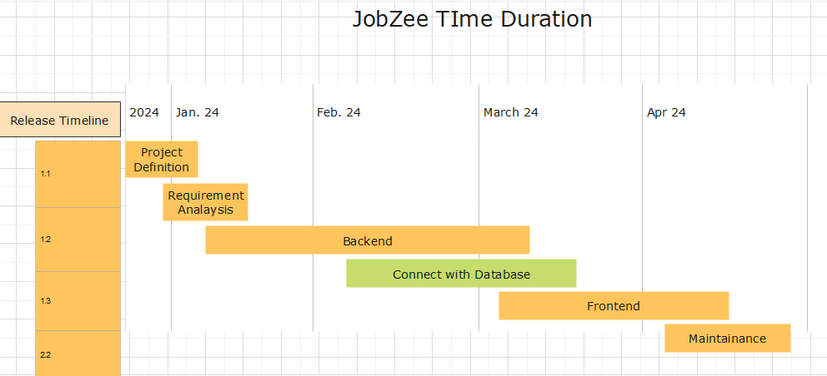

**TECHNOLOGY USED**

* **Front-end:**
  + React.js
  + CSS
* **Back-end:**
  + Node.js
  + Express.js
* **Database:**
  + MongoDB
* **Cloud Storage:**
  + Cloudinary
* **API Testing:**
  + Postman
* **Code Editor:**
  + VS Code
* **Authentication:**
  + JSON Web Tokens (JWT)
* **Encryption:**
  + bcrypt

**FUNCTIONAL AND NON- FUNCTIONAL DEPENDENCY**

**Functional Dependency**

* If the user has an account with the "Employer" role, then they can log in for Employer role
* If the user has an account with the “Job Seeker” role,then they can login for Job Seeker role.
* If the user does not have an account, then they can register by providing their name, role, email, and password.
* If the user is an employer, then they can access all the jobs on the platform.
* If the user is a job seeker, then they can access all the jobs on the platform.
* If the use is Job Seeker,so  clicks on a job posting, then they can view the details of the job posting.
* If the user is an employer, then they can view the resumes and job details of potential candidates.
* If the user is an employer, then they can post a new job on the platform.
* If the user is an employer, then they can access the jobs they have posted and view the details of each job.
* If the user is an employer, then they can edit and delete the jobs they have posted.
* If the user is a job seeker, then they can view which jobs they have applied for.
* If the user is a job seeker, then they can view the resumes and job details of the jobs they have applied for.
* If the user is a job seeker, then they can delete their applications where they have applied.

**Non-Functional Dependency**

* The system should be able to handle a large number of users and jobs without any significant performance degradation.
* The system should ensure that the user's personal information is securely stored and transmitted.
* The system should be easy to use and navigate for both employers and job seekers.
* The system should be available 24/7 for both employers and job seekers.
* The system should be able to scale up

**UML Diagram**

**System Flow Diagram(Employer)**

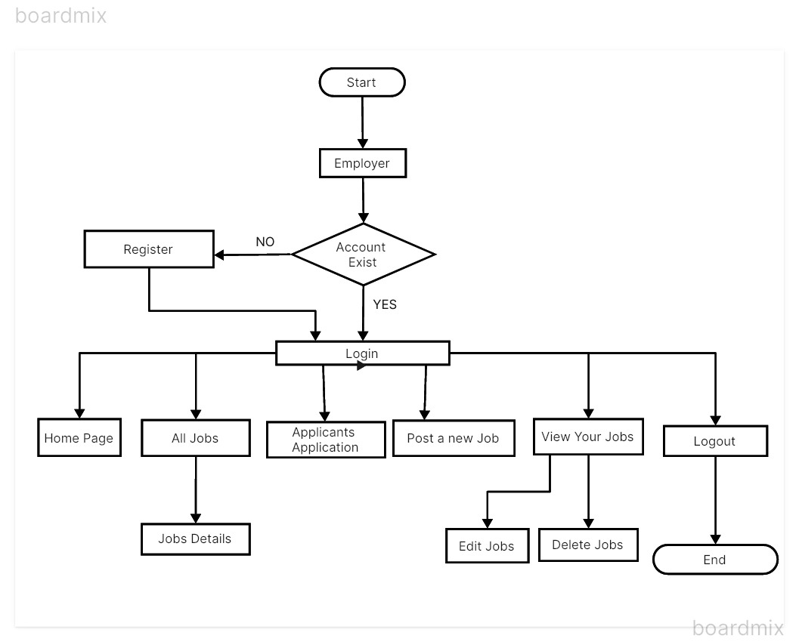

**System Flow Diagram(Job Seeker)**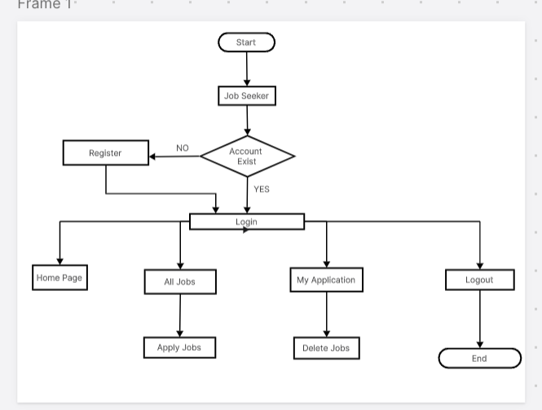

**Use Case Diagram**

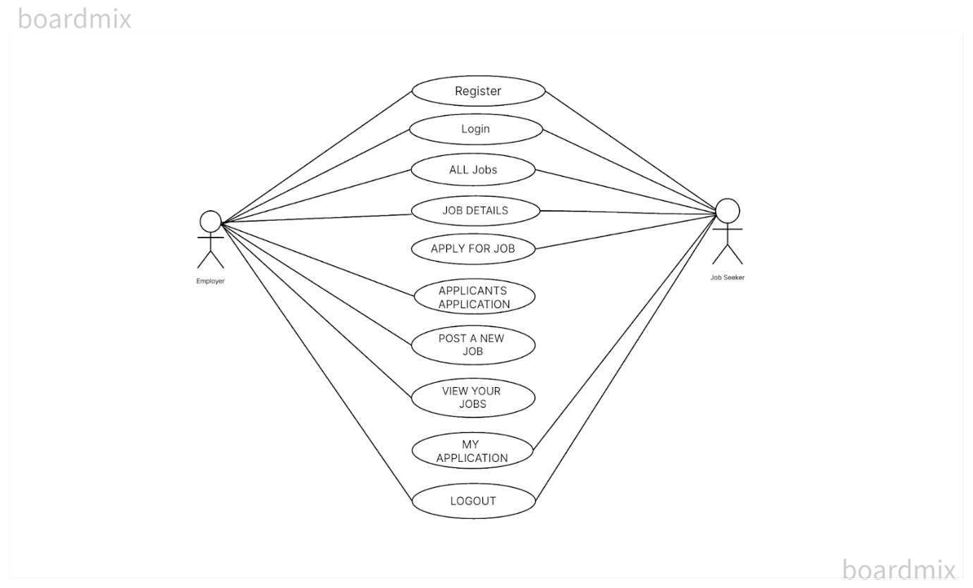

**Activity Diagram(Employer)**

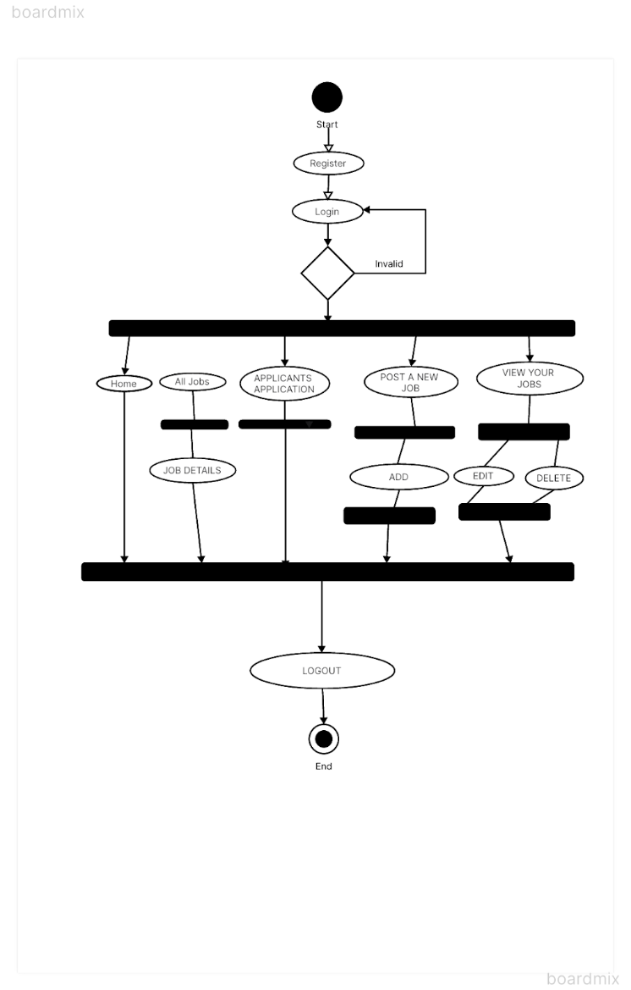

**Activity Diagram(Job Seeker)**

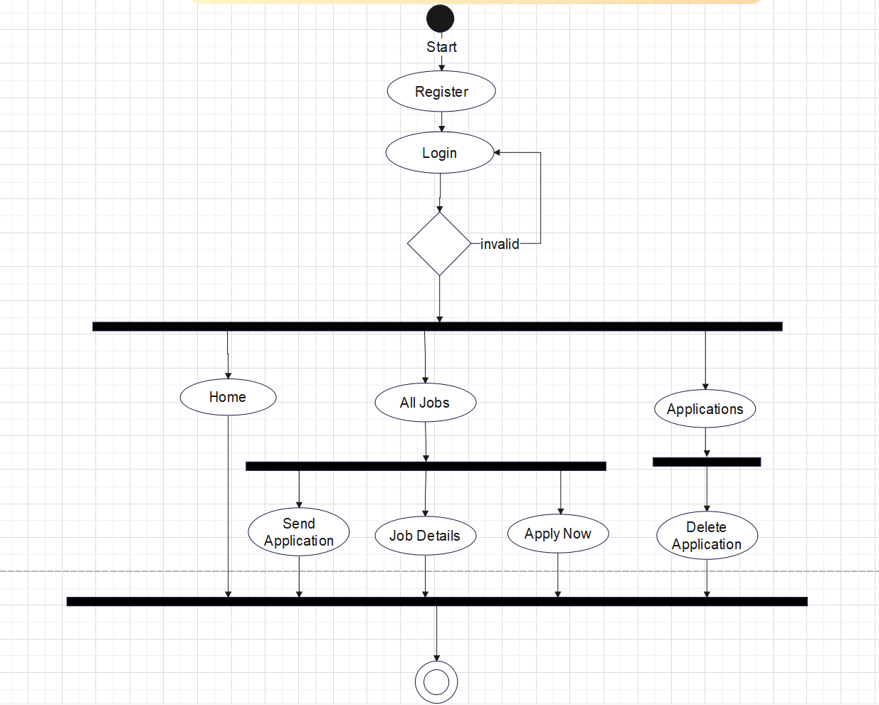

**Sequence Diagram(Employer)**

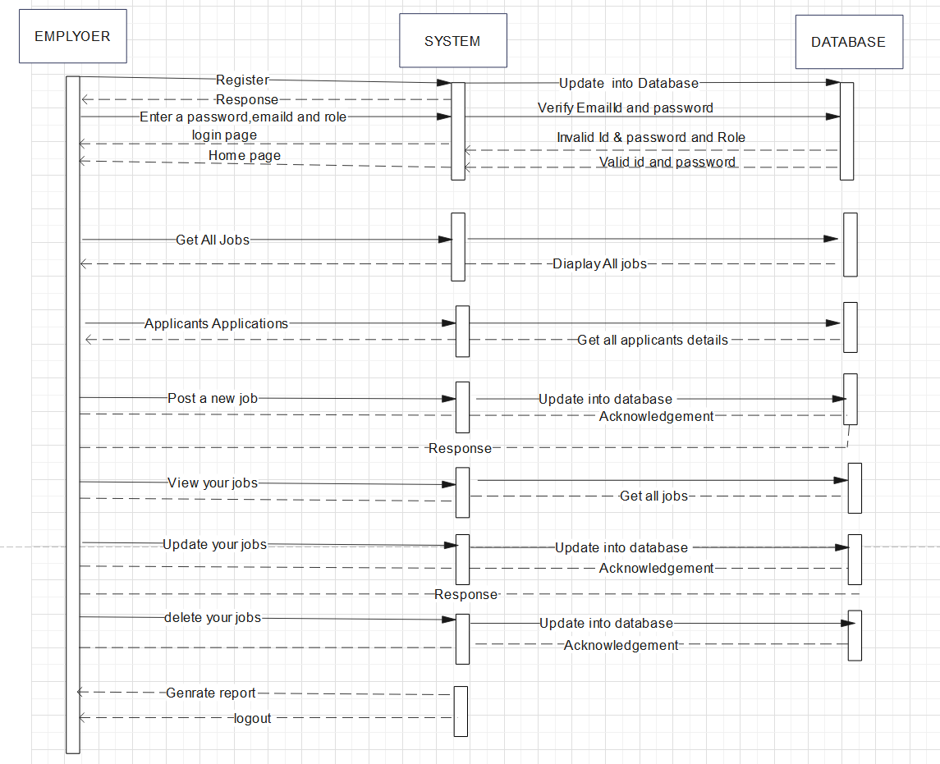

**Sequence Diagram(Job Seeker)**

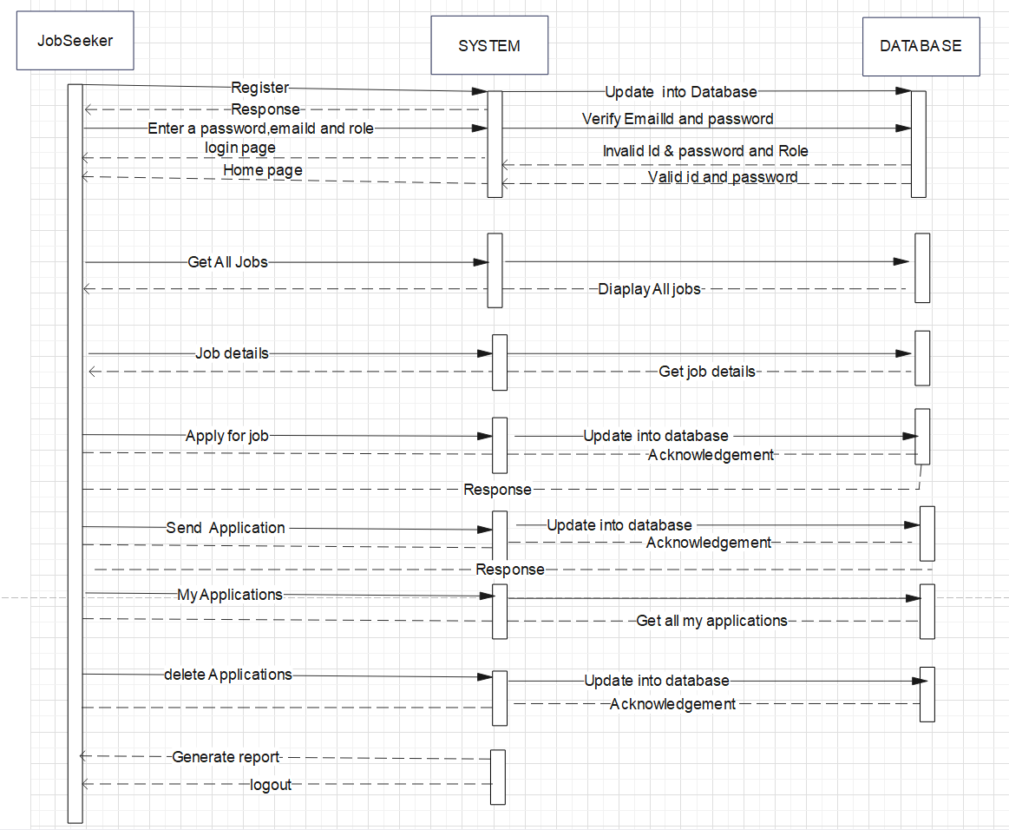

**Class Diagram**

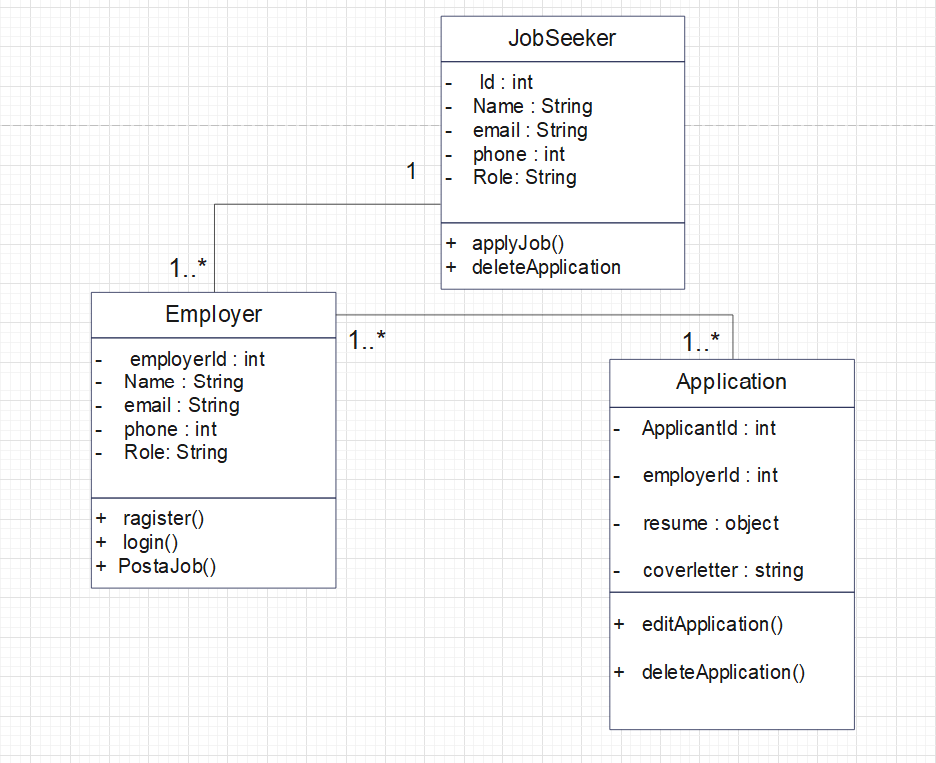

**ER-Diagram**

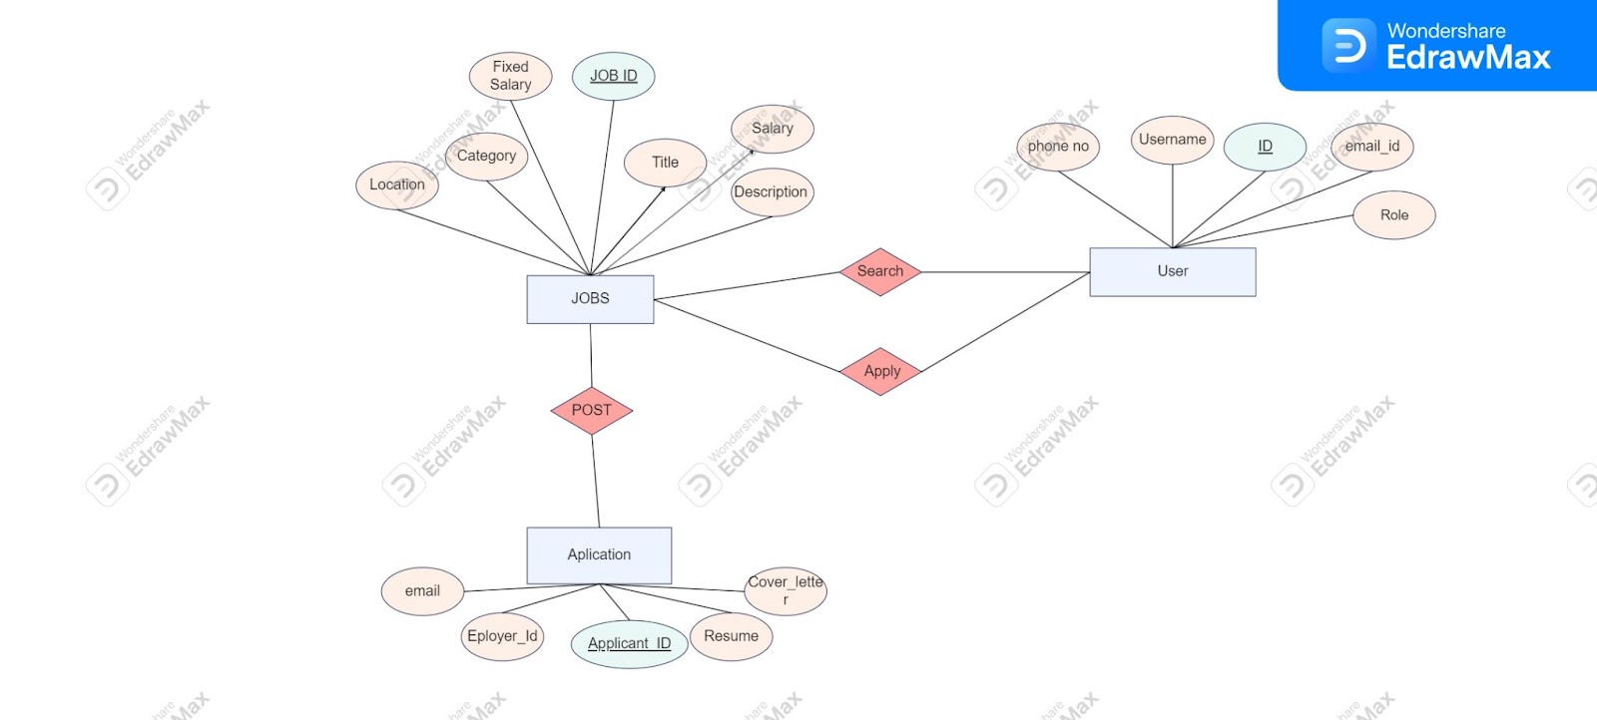

**Data Dictionary**

**User Table**

|  |  |  |
| --- | --- | --- |
| **Column Name** | **Data Type** | **Required** |
| Name | String | true |
| Email | Email | true |
| Phone | Number | true |
| Password | Password | true |
| Role | Enum | true |

**Job Table:-**

|  |  |  |
| --- | --- | --- |
| **Column Name** | **Data Type** | **Required** |
| Title | String | true |
| Description | String | true |
| Category | String | true |
| Country | String | true |
| City | String | true |
| Location | String | true |
| Fixed Salary | Number |  |
| Salary From | Number |  |
| Salary To | Number |  |
| Expired | Boolean |  |
| Job Posted On | Date |  |
| Posted By | Object |  |

**Application Table:-**

|  |  |  |
| --- | --- | --- |
| **Column Name** | **Data Type** | **Required** |
| Name | String | true |
| Email | Email | true |
| Cover Letter | String | true |
| Phone | Number | true |
| Address | String | true |
| Resume | Object | true |
| applicantId | Object |  |
| employerId | Object |  |

**Screen Shots:-**

**Login**

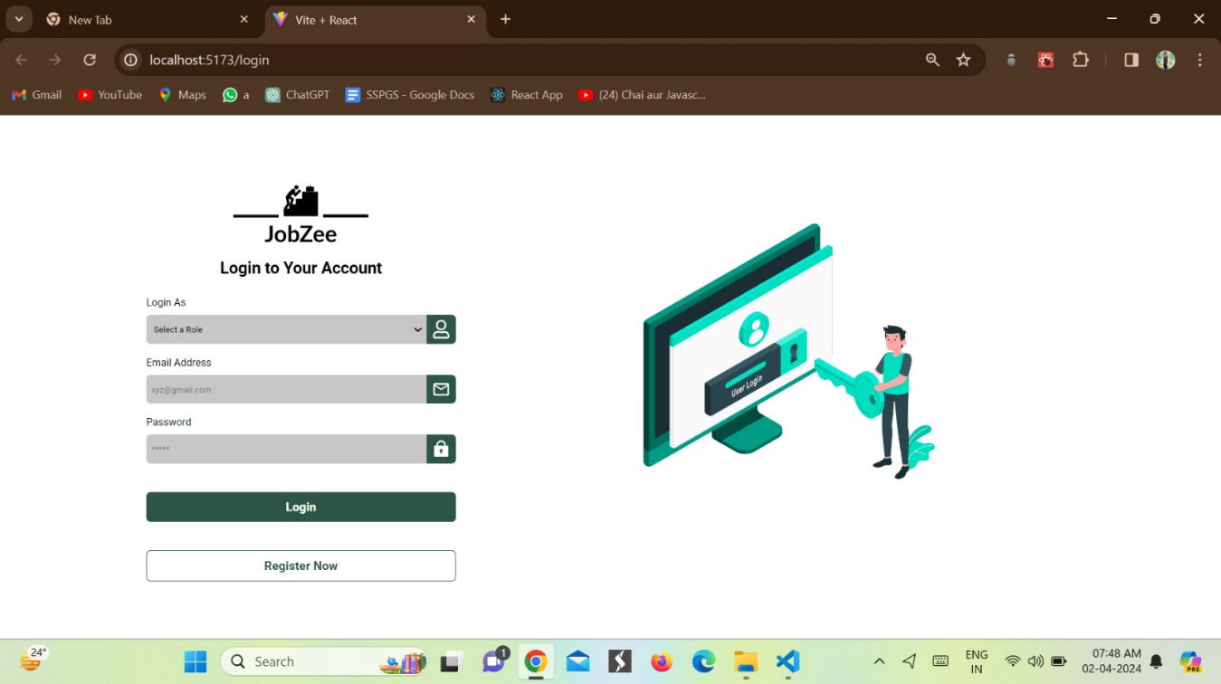

**Register:-**

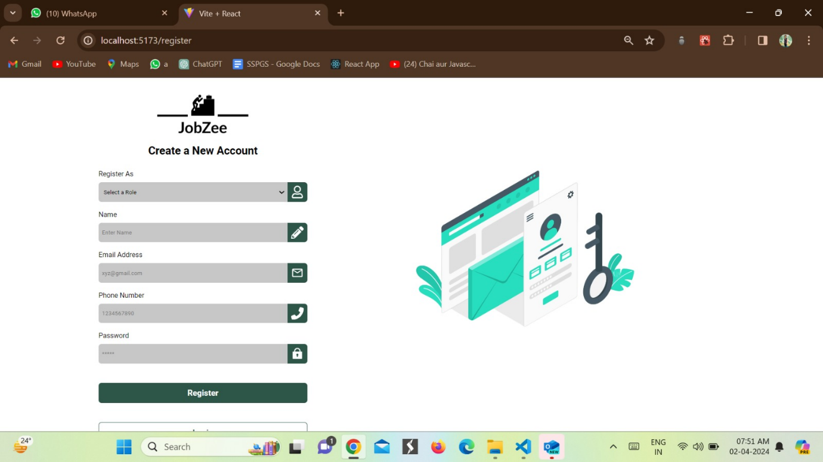

**Job Seeker Home Page:-**

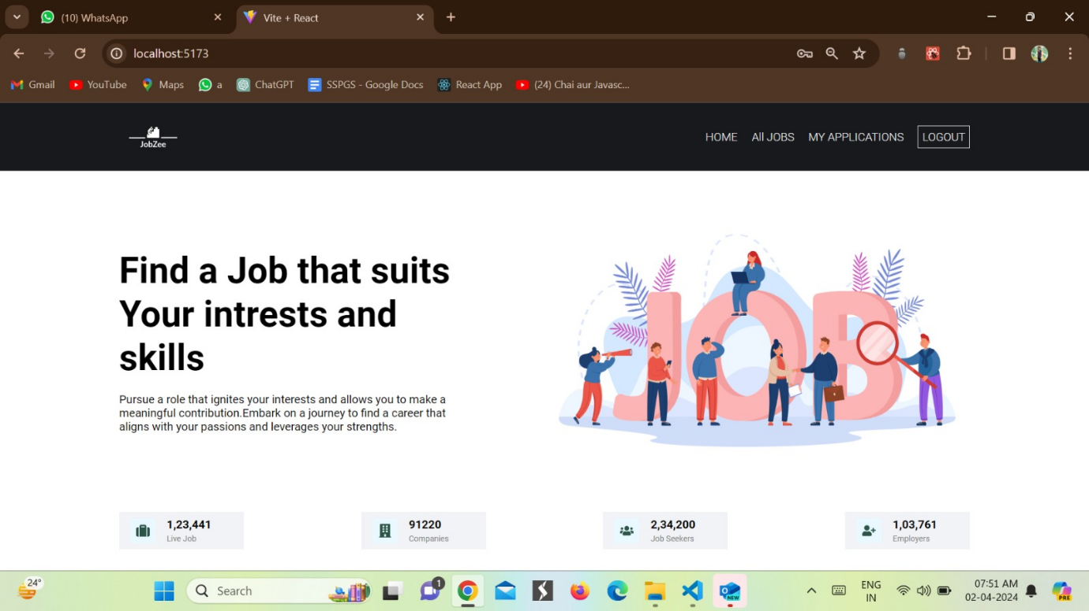

**Job Seeker All Job**

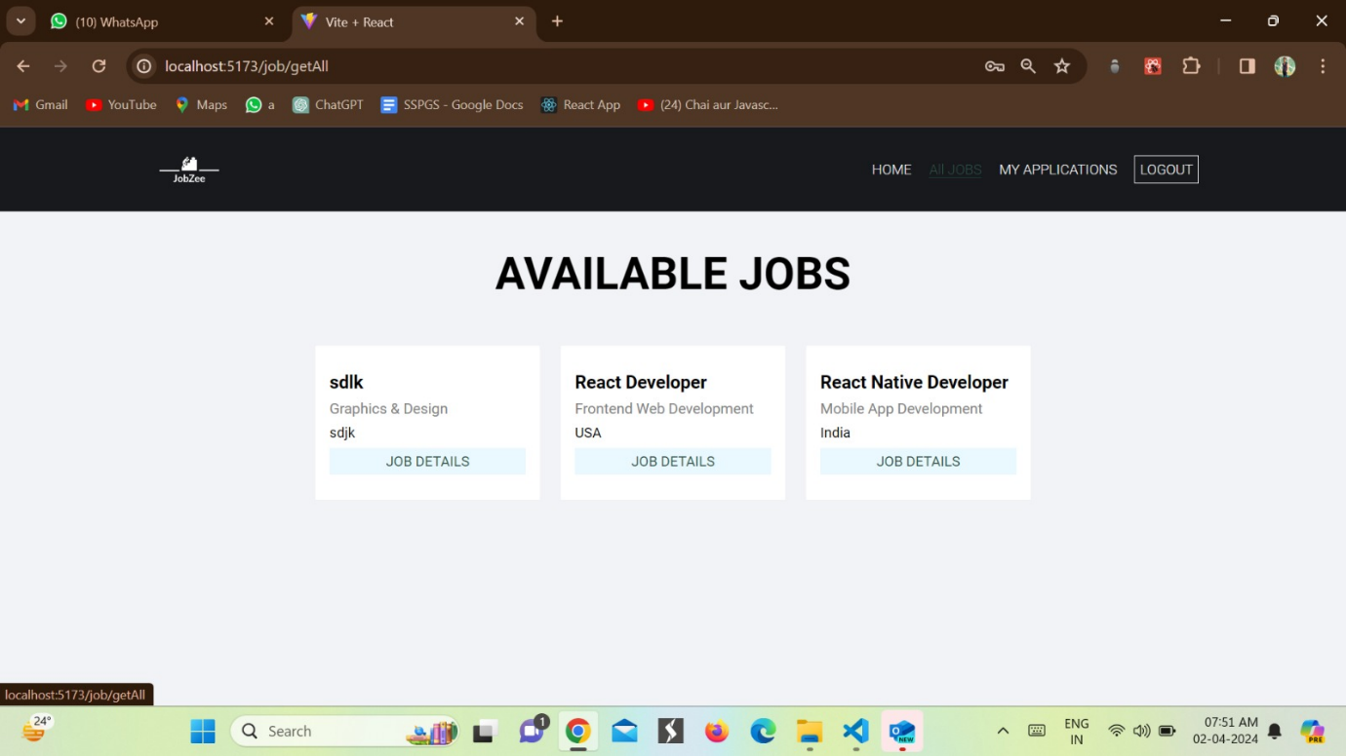

**Job Details**

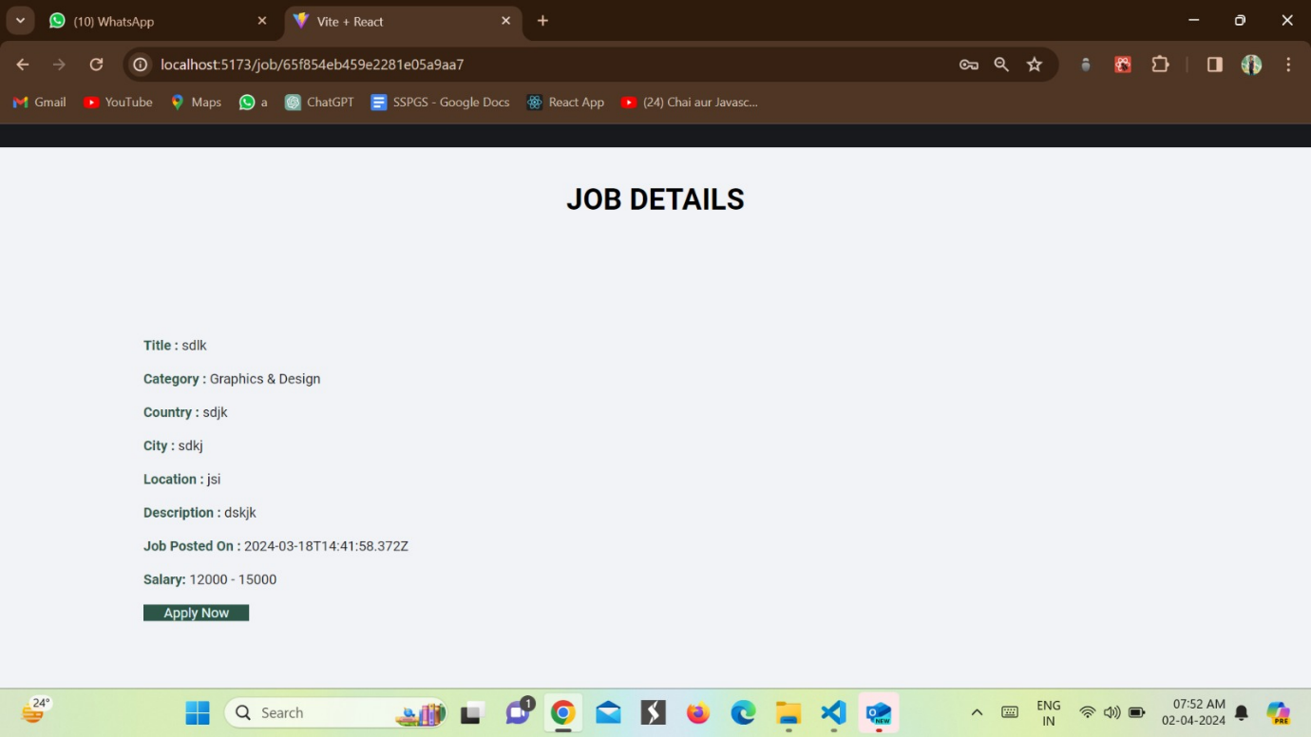

**Job Application Form**

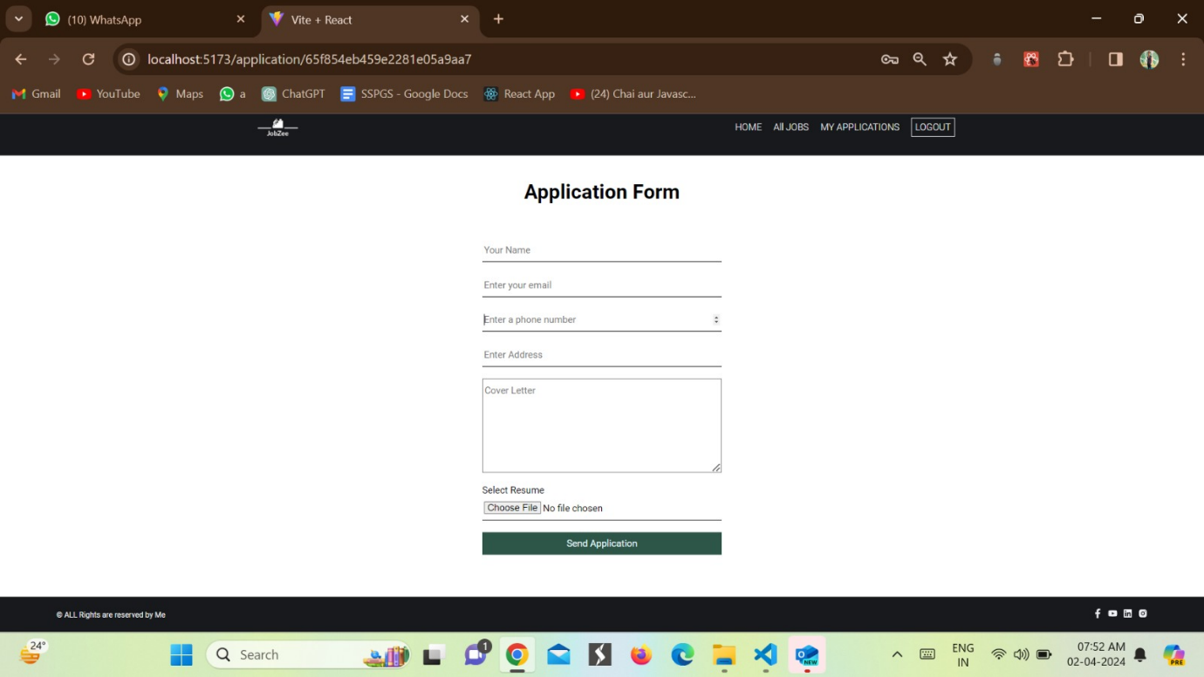

**Applicants Status:-**

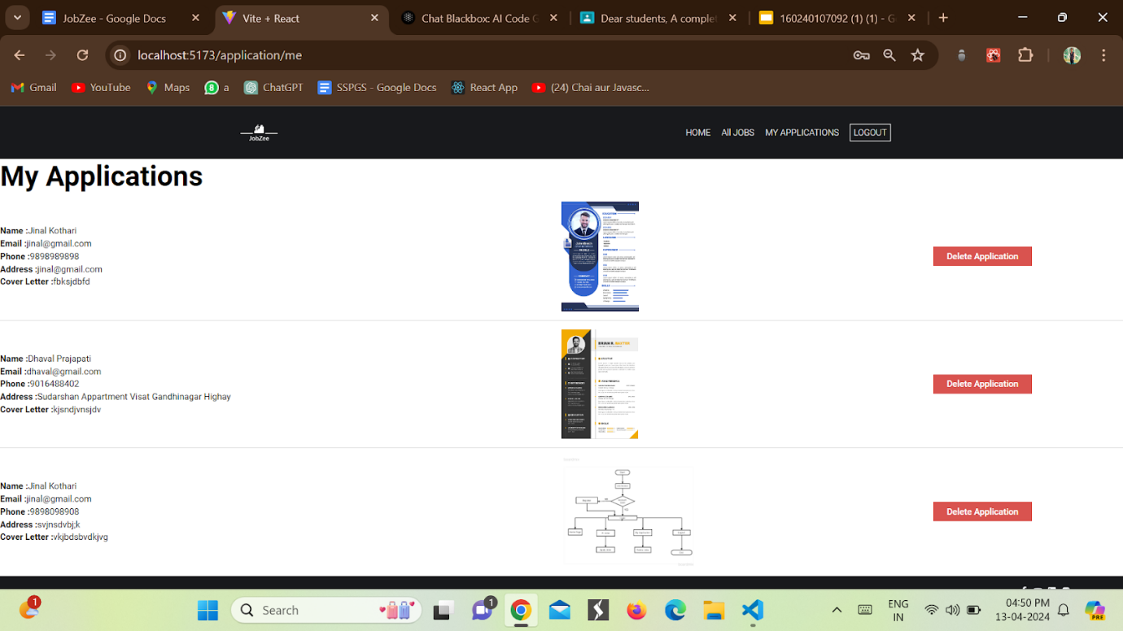

**Employer Home Page**

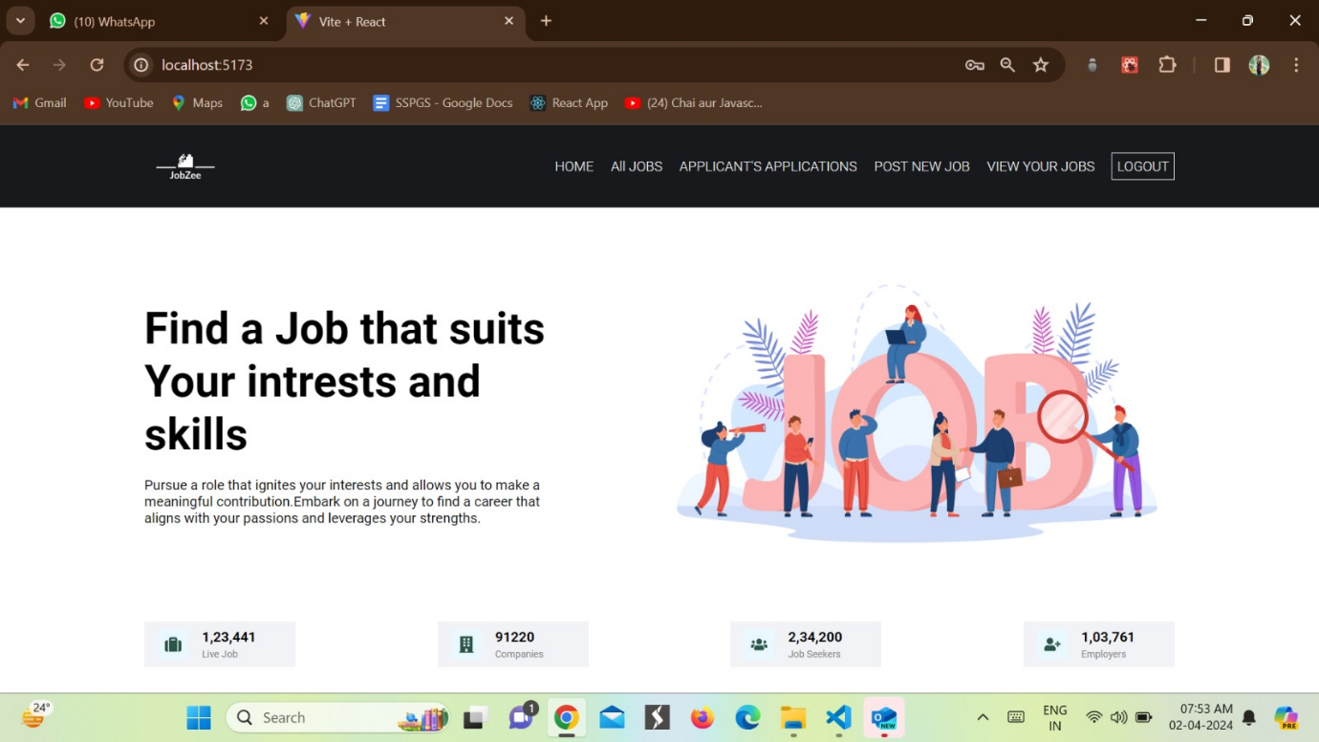

**All Job For Employer**

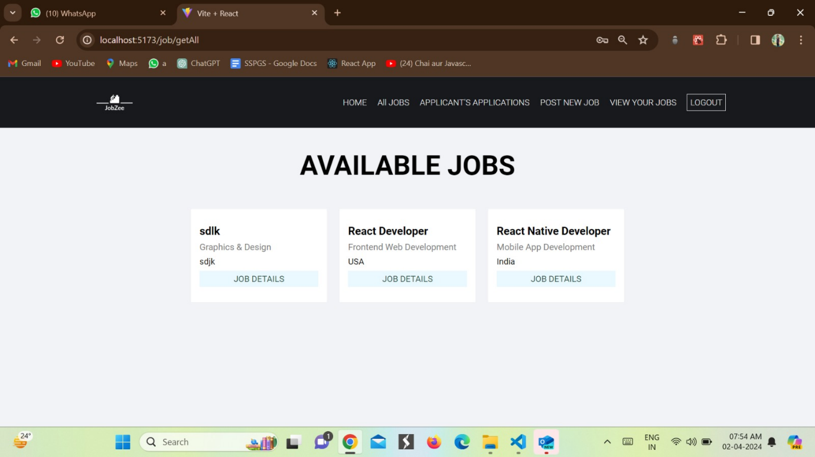

**Job Details for Employer**

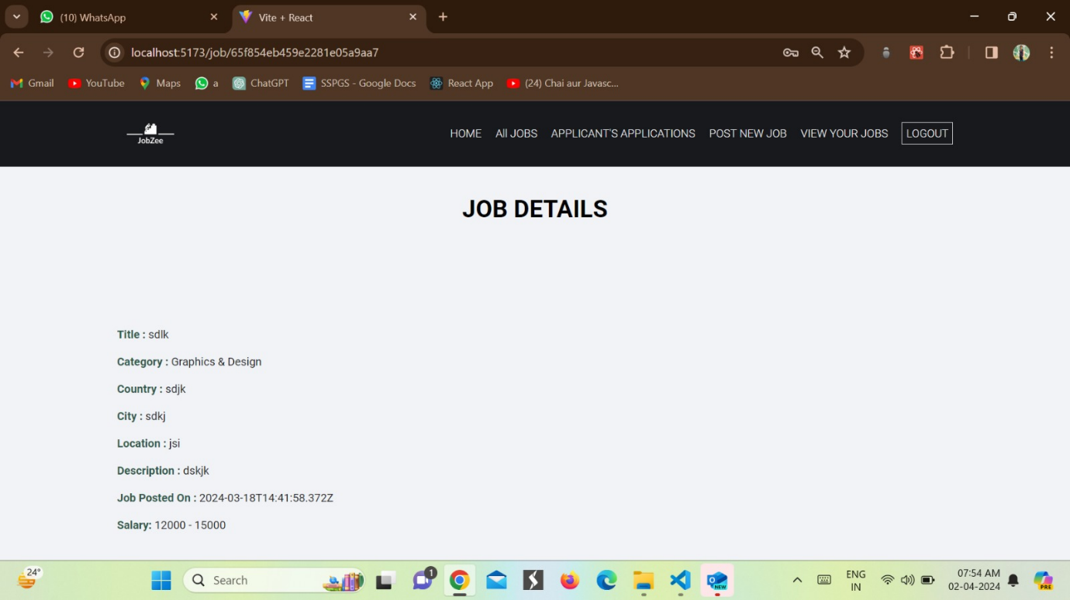

**Applicant Application**

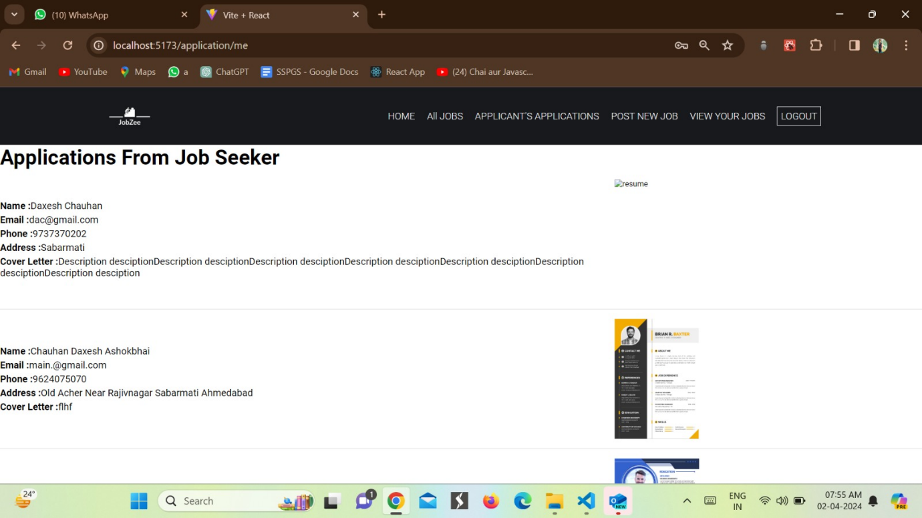

**Post a Job by Employer**

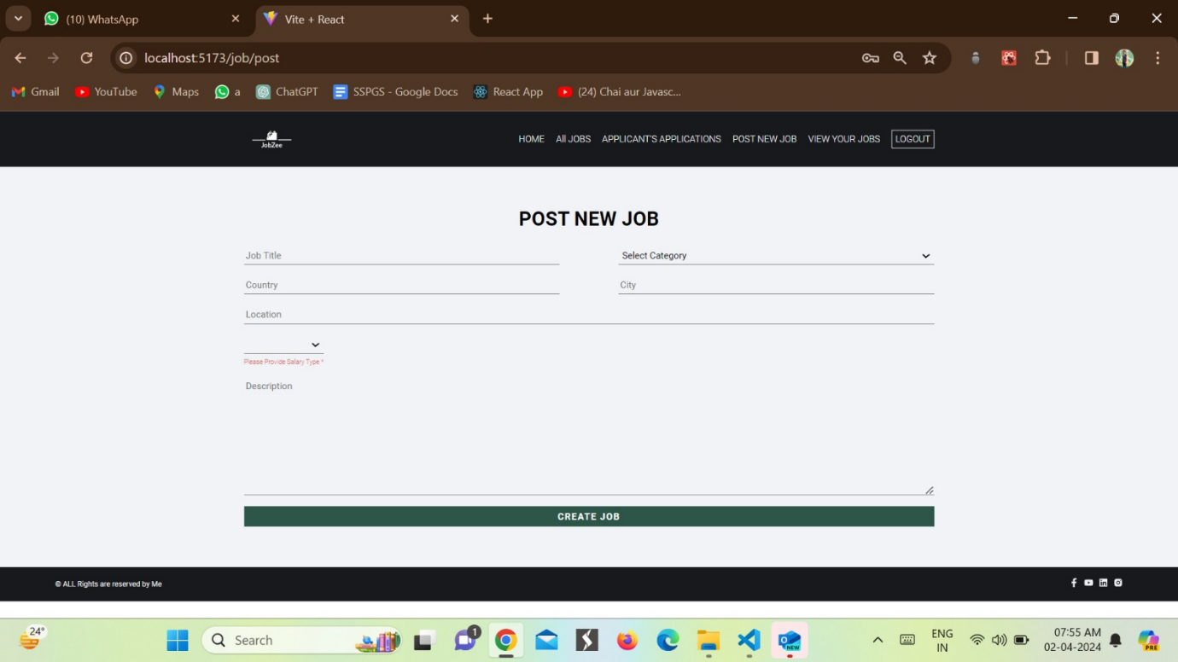

**View Job Posted by Employer**

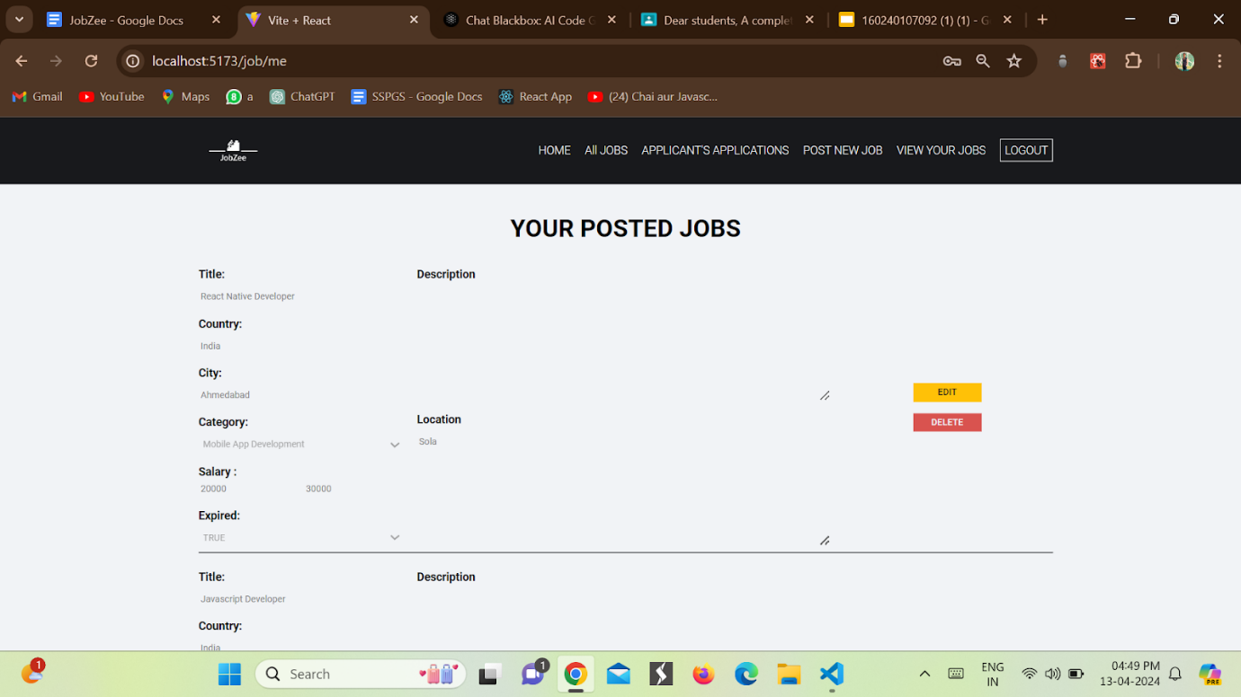

**Edit a Job**

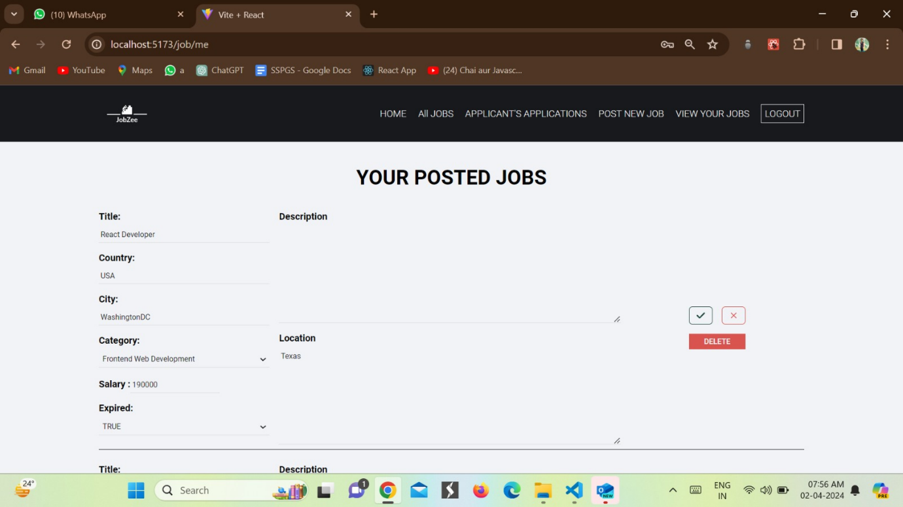

**Expected Outcomes:-**

   Improved job seeking and management process for organizations: Our job hiring website will provide a centralized platform for organizations to manage their job opportunities, making it easier for them to connect with qualified candidates and efficiently use their resources.

Increased visibility and access to job opportunities for job seekers: The website will offer a user-friendly interface for job seekers to search and apply for relevant job opportunities, increasing their chances of finding and securing their desired positions.

Streamlined communication and application process: The website will facilitate seamless communication between organizations and job seekers, reducing the time and effort required to manage job applications and inquiries.

**Future Scope**

* Integration with social media platforms for easier job sharing and promotion
* Implementing a recommendation engine to suggest jobs to job seekers based on their interests and qualifications
* Adding a chatbot for quick and easy communication between employers and job seekers
* Developing a mobile app for job seekers to easily search and apply for jobs on-the-go
* Incorporating video interviews to streamline the hiring process and reduce travel costs
* Offering premium features for employers, such as advanced search filters and analytics
* Providing career development resources for job seekers, such as resume building tools and interview tips
* Expanding to include freelance and gig job opportunities
* Integrating with background check services to provide a more comprehensive hiring solution for employers
* Developing partnerships with educational institutions to provide job training and placement services for students and recent graduates.

**References:-**

1.LinkedIn:-<https://in.linkedin.com/>

2.Indeed - <https://in.indeed.com/?r=us>

3.Naukri-<https://in.naukri.com/>

